2024 ASBESTOS REGISTER – GRANT (Building 11), Rockhampton Girls Grammar School
Date of register: 05/08/2024
NOTE: A demolition or refurbishment survey should be carried out by a competent person before undertaking refurbishment or demolition work.
Workplace address: |  | Rockhampton Girls  Grammar School –  Denham Street,  Rockhampton City QLD 4700 |  | Name and contact details of competent person: | Lawrence Lyons  Asbestos Assessor Licence No. 2317266  Environics (QLD) Pty Ltd  ABN 76 354 368 913  Tel. 0429 128 145 |  | Workplace owner / manager: | Kasey Mitchell  Facilities and Services Manager Rockhampton Girls Grammar School  Tel. 0427 414 819
Areas not assessed: |  | Ceiling cavities located beyond inspection openings, utility pits, and elevated areas where safety measures cannot be practically implemented.
Asbestos related  documents: |  | ENV-2023-062 Ver 1-4 Asbestos Management Plan & ACM Register - RGGS, Denham St The Range Q 4700.pdf  - Appendix One ENV-2023-062-RGGS-ASBESTOS REGISTER-v1-02.10.2024. (this document)  - Appendix Two RGGS-691-PRO-ASBESTOS-MANAGEMENT-PROCEDURE-v1-24.07.2024  - Appendix Three RGGS-692-PRO-ASBESTOS-INCIDENT-MANAGEMENT-PROCEDURE-v1-24.07.2024  - Appendix Four RGGS-720-GDL-ASBESTOS-MANAGEMENT-POSTER-v1-24.07.2024
Consultation: |  | Attach minutes of relevant future meeting to this document.
Disclaimer and  Limitations: |  | Inspections were limited to accessible areas without dismantling or removing objects, including vegetation, insulation, coverings, furnishings, and personal belongings. Areas such as inside walls, between floors, and behind stored items were not inspected. No destructive procedures were performed, and relevant legislation was followed. For further details on regulations, please refer to additional materials. Compliance and Liability: This register does not serve as a 'Certificate of Compliance' unless specified and does not warranty against future asbestos issues. The report does not confirm that all areas are asbestos-free. The competent person is not liable for undetectable asbestos requiring structural disruption.
Date | Sample No. | Type of material identified or assumed and amount  (Cross-sectional areas  are estimates – measure before quoting) | Friable or non-friable asbestos | Condition of asbestos | Specific location of identified or assumed asbestos | Notes
05/08/2024 | ENV001 | Chrysotile  >40m² | Non-friable unless removed using an abrasive method of removal i.e. lift & grinding concrete | Fair condition with an area of cracked tiles at center of room | Interior:  Vinyl floor tiles to the Art room below the G1class room | COHLABS Certificate of Analysis 24-9180  Recommend removed during 2025 due to area of poor condition at center of room.
05/08/2024 | G5 | Chrysotile >50m² | Non-friable | Fair | Internal wall & ceiling sheeting to the fire escape stairwell on the southern side of the building | 19 October 2013 – SLR report:  A number of asbestos labels were sighted

.

Page 1 of 4

2024 ASBESTOS REGISTER – GRANT (Building 11), Rockhampton Girls Grammar School
NOTE: A demolition or refurbishment survey should be carried out by a competent person before undertaking refurbishment or demolition work.
NON-ASBESTOS MATERIALS

The following materials were tested and found not to contain asbestos:

Date | Sample  No. | Result of Analysis | Location | Notes
05/08/2024 | P7 | No Asbestos fibre detected | Exterior:  External ceiling sheeting to the covered walkway off the Dining-Lounge-Laundry | 19 October 2013 – SLR report:
05/08/2024 | P8 | No Asbestos detected. | Exterior:  Fibrous sheeting to the ground floor sunshades located to the building - Fibrous sheeting to the level 1 sunshades located to the building | 19 October 2013 – SLR report:  Sampling of ground floor sunshades on western side of building do not contain asbestos. No access to sunshades on north, east and south sides of building - presumed to contain asbestos.
 |  |  | The desktop review of historical records, including Asbestos Removal Control Plans (ARCPs), Asbestos Clearance Certificates, and additional documentation, coupled with the walkthrough inspection, verified that asbestos-containing materials (ACMs) have been removed and that modern renovations have taken place.

Page 2 of 4

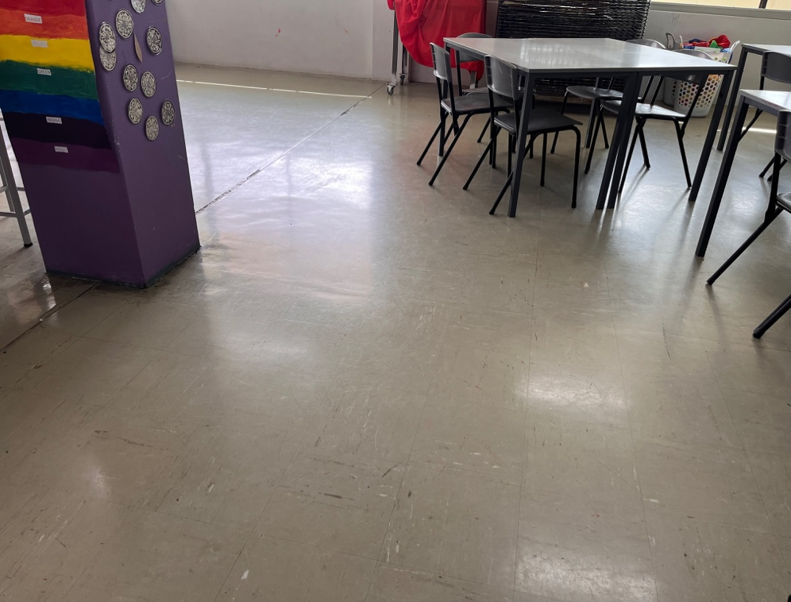 | 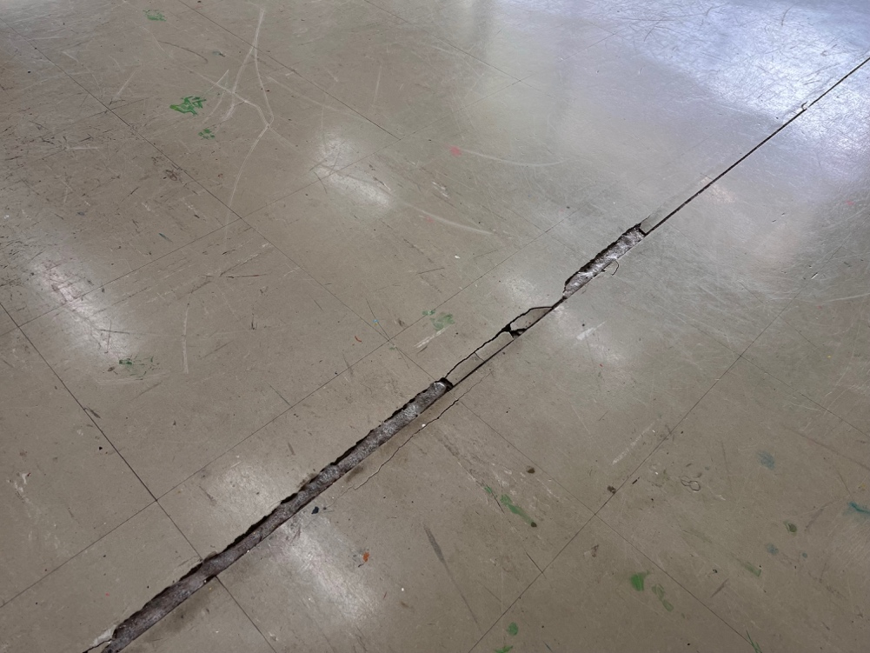
Vinyl tiles containing asbestos | Area were cracking of tiles has occurred

Page 3 of 4

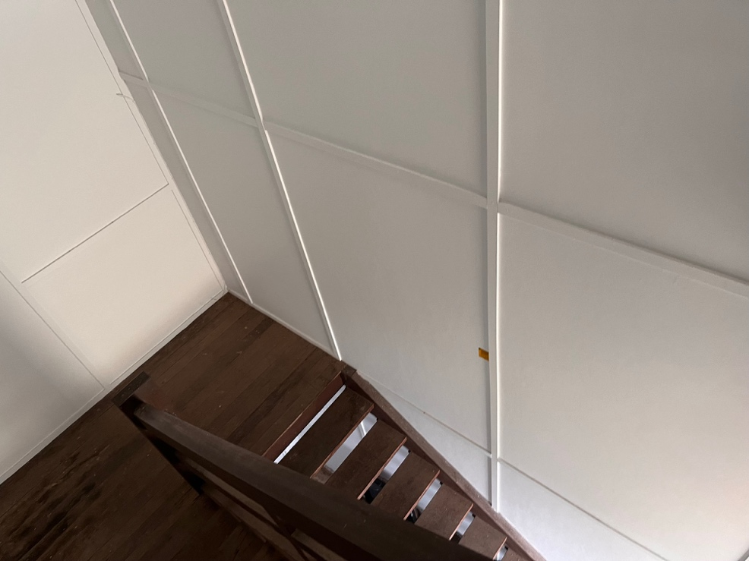 | 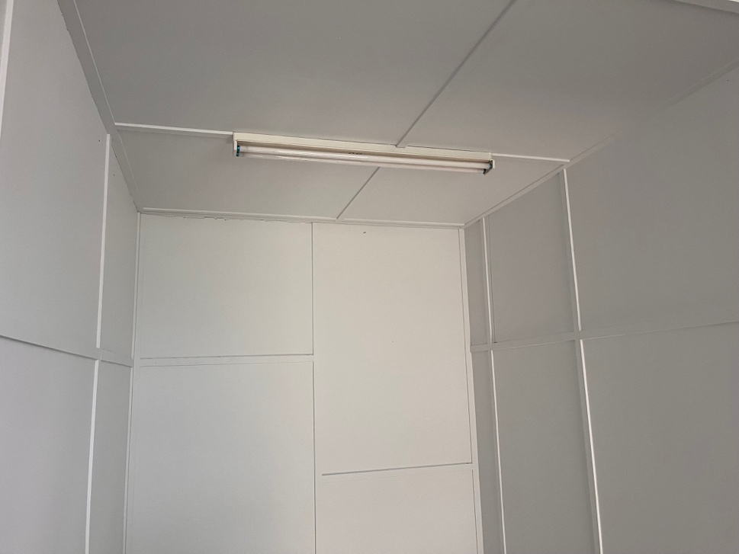
Asbestos cement wall sheeting – stairwell southern end of building | Asbestos cement ceiling sheeting – stairwell southern end of building

Page 4 of 4

