2024 ASBESTOS REGISTER – HERITAGE PLAYSHED (Building 17), Rockhampton Girls Grammar School
Date of register: 06/06/2024
NOTE: A demolition or refurbishment survey should be carried out by a competent person before undertaking refurbishment or demolition work.
Workplace address: |  | Rockhampton Girls  Grammar School –  Denham Street,  Rockhampton City QLD 4700 |  | Name and contact details of competent person: | Lawrence Lyons  Asbestos Assessor Licence No. 2317266  Environics (QLD) Pty Ltd  ABN 76 354 368 913  Tel. 0429 128 145 |  | Workplace owner / manager: | Kasey Mitchell  Facilities and Services Manager Rockhampton Girls Grammar School  Tel. 0427 414 819
Areas not assessed: |  | Ceiling cavities located beyond inspection openings, utility pits, and elevated areas where safety measures cannot be practically implemented.
Asbestos related  documents: |  | ENV-2023-062 Ver 1-4 Asbestos Management Plan & ACM Register - RGGS, Denham St The Range Q 4700.pdf  - Appendix One ENV-2023-062-RGGS-ASBESTOS REGISTER-v1-02.10.2024. (this document)  - Appendix Two RGGS-691-PRO-ASBESTOS-MANAGEMENT-PROCEDURE-v1-24.07.2024  - Appendix Three RGGS-692-PRO-ASBESTOS-INCIDENT-MANAGEMENT-PROCEDURE-v1-24.07.2024  - Appendix Four RGGS-720-GDL-ASBESTOS-MANAGEMENT-POSTER-v1-24.07.2024
Consultation: |  | Attach minutes of relevant future meeting to this document.
Disclaimer and  Limitations: |  | Inspections were limited to accessible areas without dismantling or removing objects, including vegetation, insulation, coverings, furnishings, and personal belongings. Areas such as inside walls, between floors, and behind stored items were not inspected. No destructive procedures were performed, and relevant legislation was followed. For further details on regulations, please refer to additional materials. Compliance and Liability: This register does not serve as a 'Certificate of Compliance' unless specified and does not warranty against future asbestos issues. The report does not confirm that all areas are asbestos-free. The competent person is not liable for undetectable asbestos requiring structural disruption.
Date | Sample No. | Type of material identified or assumed and amount  (Cross-sectional areas  are estimates – measure before quoting) | Friable or non-friable asbestos | Condition of asbestos | Specific location of identified or assumed asbestos | Notes
10/04/2024 | PF1 | Chrysotile 24m² | Non-friable unless removed by abrasive means, i.e. floor grind after lifting | Fair | Interior:  Storerooms 5, 6, 7 & 8 | 19 October 2013 – SLR report:  Vinyl floor tiles to the storerooms 5, 6, 7 & 8 along with the Stationery Store - Chrysotile Asbestos fibre detected.
10/04/2024 | PF2 | Chrysotile  65 to 85 m² | Non-friable | Poor to Fair | Interior:  Walls of storerooms and room 8, walls for former shop, canteen & dressing rooms. Partition walls between rooms. Infill panel on north wall in north eastern closed storage, second hand clothes room, all outer walls to store rooms | 19 October 2013 – SLR report:  Rep sample of internal wall sheeting to storeroom, room no. 8 - Chrysotile Asbestos fibre detected the sheeting to storerooms, uniform shop, canteen & dressing rooms, walls and partition walls run up and to the beginning of the ceiling cavity.  Several walls were found to be plaster or canite.

Page 1 of 3

2024 ASBESTOS REGISTER – HERITAGE PLAYSHED (Building 17), Rockhampton Girls Grammar School
Date of register: 06/06/2024
NOTE: A demolition or refurbishment survey should be carried out by a competent person before undertaking refurbishment or demolition work.
Date | Sample No. | Type of material identified or assumed and amount  (Cross-sectional areas  are estimates – measure before quoting) | Friable or non-friable asbestos | Condition of asbestos | Specific location of identified or assumed asbestos | Notes
10/04/2024 | PF4 | Chrysotile  120 m² | Non-Friable | Fair | Exterior:  Wall sheeting and cover strips of building | 19 October 2013 – SLR report:  External wall sheeting and cover strips to the Building - Chrysotile Asbestos fibre detected
10/04/2024 | S14 | Chrysotile  12 m² | Non-Friable | Fair | Interior:  Wall of western elevation of main room | Sampled during the 2024 inspections.
10/04/2024 | S15 | Chrysotile  12 m² | Non-Friable | Fair | Interior:  Wall adjacent to north entry to building | Sampled during the 2024 inspections.

Page 2 of 3

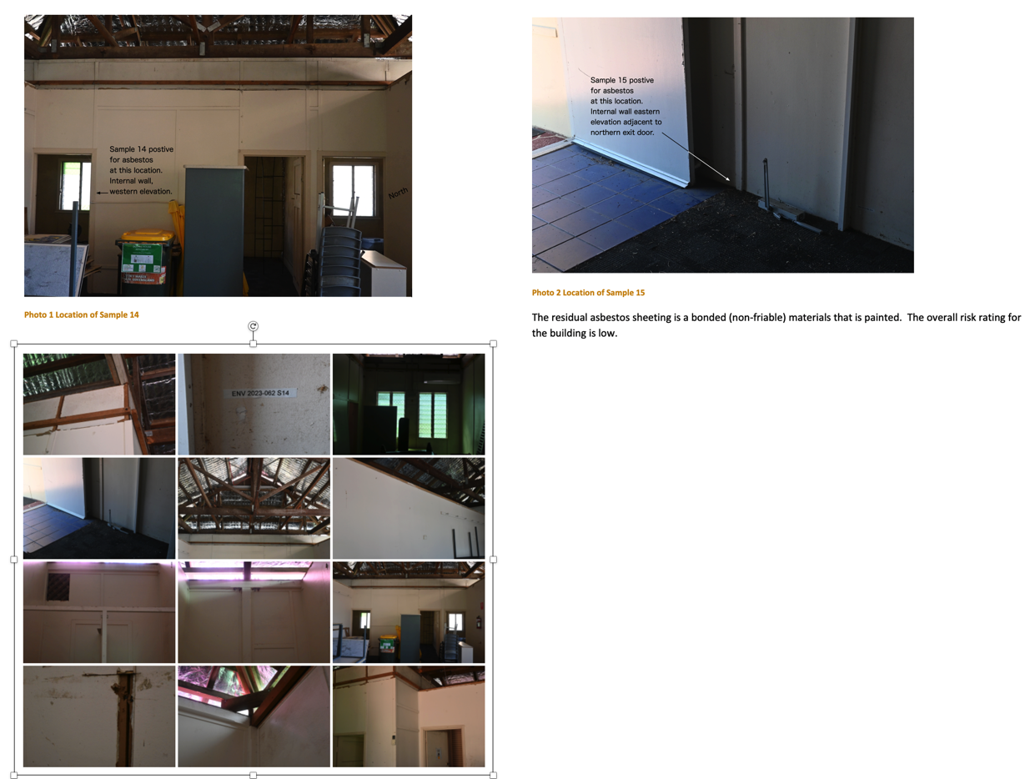

Page 3 of 3

