2024 ASBESTOS REGISTER – FLORENCE HOUSE, Rockhampton Girls Grammar School
Date of register: 06/06/2024
NOTE: A demolition or refurbishment survey should be carried out by a competent person before undertaking refurbishment or demolition work.
Workplace address: |  | Rockhampton Girls  Grammar School –  Denham Street,  Rockhampton City QLD 4700 |  | Name and contact details of competent person: | Lawrence Lyons  Asbestos Assessor Licence No. 2317266  Environics (QLD) Pty Ltd  ABN 76 354 368 913  Tel. 0429 128 145 |  | Workplace owner / manager: | Kasey Mitchell  Facilities and Services Manager Rockhampton Girls Grammar School  Tel. 0427 414 819
Areas not assessed: |  | Ceiling cavities located beyond inspection openings, utility pits, and elevated areas where safety measures cannot be practically implemented.
Asbestos related  documents: |  | ENV-2023-062 Ver 1-4 Asbestos Management Plan & ACM Register - RGGS, Denham St The Range Q 4700.pdf  - Appendix One ENV-2023-062-RGGS-ASBESTOS REGISTER-v1-02.10.2024. (this document)  - Appendix Two RGGS-691-PRO-ASBESTOS-MANAGEMENT-PROCEDURE-v1-24.07.2024  - Appendix Three RGGS-692-PRO-ASBESTOS-INCIDENT-MANAGEMENT-PROCEDURE-v1-24.07.2024  - Appendix Four RGGS-720-GDL-ASBESTOS-MANAGEMENT-POSTER-v1-24.07.2024
Consultation: |  | Attach minutes of relevant future meeting to this document.
Disclaimer and  Limitations: |  | Inspections were limited to accessible areas without dismantling or removing objects, including vegetation, insulation, coverings, furnishings, and personal belongings. Areas such as inside walls, between floors, and behind stored items were not inspected. No destructive procedures were performed, and relevant legislation was followed. For further details on regulations, please refer to additional materials. Compliance and Liability: This register does not serve as a 'Certificate of Compliance' unless specified and does not warranty against future asbestos issues. The report does not confirm that all areas are asbestos-free. The competent person is not liable for undetectable asbestos requiring structural disruption.
Date | Sample No. | Type of material identified or assumed and amount  (Cross-sectional areas  are estimates – measure before quoting) | Friable or non-friable asbestos | Condition of asbestos | Specific location of identified or assumed asbestos | Notes
06/06/2024 | GF-F3-8 | Chrysotile & Amosite Asbestos  10m² | Friable | Painted & in good condition | Interior:  North wall behind shower/toilets  closest to hall | 19 October 2013 SLR report:  North wall behind shower/toilets closest to hall - Chrysotile & Amosite Asbestos detected - LOW DENSITY BOARD. Sample GF-F3-8. (Photo 270, 10m2)
06/06/2024 | GF-F3-9 | Chrysotile Asbestos  2m² | Non-friable | Painted & in good condition | Interior:  North wall behind shower/toilets  closest to hall | 19 October 2013 SLR report:  Upper east wall behind shower/toilets closest to hall - Chrysotile Asbestos detected. Sample GF-F3-9. (Photo 271, 2m2)
06/06/2024 | GF-F2 | Chrysotile Asbestos  2m² | Non-friable | Painted & in good condition | Interior:  North wall behind shower/toilets  closest to hall | 19 October 2013 SLR report:  Internal wall sheeting to the Laundry - Chrysotile Asbestos fibre detected.

.
Page 1 of 5

2024 ASBESTOS REGISTER – FLORENCE HOUSE, Rockhampton Girls Grammar School
Date of register: 06/06/2024
NOTE: A demolition or refurbishment survey should be carried out by a competent person before undertaking refurbishment or demolition work.
Date | Sample No. | Type of material identified or assumed and amount  (Cross-sectional areas  are estimates – measure before quoting) | Friable or non-friable asbestos | Condition of asbestos | Specific location of identified or assumed asbestos | Notes
06/06/2024 | GF-F1 | Chrysotile Asbestos  3 m² | Non-friable unless removed using an abrasive method of removal i.e. lift & grinding concrete | Fair condition | Interior:  Vinyl tiles to the Laundry floor | 19 October 2013 SLR report:  Vinyl tiles to the Laundry floor –  Chrysotile Asbestos fibre detected.
06/06/2024 | GF-F3-11 | Chrysotile & Amosite Asbestos  9 m² | Confirm type using pentation test following removal of Tilux cover sheet before quoting to remove (amosite present) | Good condition | Interior:  South wall behind Tilux sheeting | 19 October 2013 SLR report:  South wall behind Tilux sheeting - Chrysotile & Amosite Asbestos detected. Sample GF-F3-11. (Photo 272, 9m2).
06/06/2024 | GF-F3-12 | Chrysotile Asbestos  8 m² | Non-friable | Good condition | Interior:  Bathroom | 19 October 2013 SLR report:  Tilux sheeting throughout bathroom - Chrysotile Asbestos detected. Sample GF-F3-12. (Photo 273, 8m2).
06/06/2024 | - | - | See SLR notes | - | Interior:  West wall (dividing wall between 2 sections of bathroom) | 19 October 2013 SLR report:  West wall (dividing wall between 2 sections of bathroom) is presumed - material is too hard to sample).
06/06/2024 | GF-F4-4 | Chrysotile & Amosite Asbestos  1 m² | Non-friable | Good condition | Interior:  Skylight in main house bathroom | 19 October 2013 SLR report:  Skylight in main house bathroom - - Chrysotile Asbestos detected. Sample GF-F4-4 (1m2).
06/06/2024 | GF-F4-2 | Chrysotile & Amosite Asbestos  3 m² | Confirm type using pentation test before quoting to remove (amosite present) | Good condition | Interior:  Ceiling to side entrance to main house (next to laundry) | 19 October 2013 SLR report:  Ceiling to side entrance to main house (next to laundry) - Chrysotile & Amosite Asbestos detected. Sample GF-F4-2. (Photo 275, 3m2).
06/06/2024 | GF-F4-3 | Chrysotile Asbestos  3 m² | Non-friable | Good condition | Interior:  Ceiling to bathroom  in residential flat | 19 October 2013 SLR report:  Ceiling to bathroom in residential flat - Chrysotile Asbestos detected. Sample GF-F4-3. (Photo 282, 3m2).
06/06/2024 | GF-F5 | Chrysotile Asbestos  > 5 m² | Non-friable | Good condition | Exterior (ground level):  Shadow line profiled wall sheeting of the residence (elevation 1) | 19 October 2013 SLR report:  The Shadow line profiled wall sheeting to the external of the Residence - Chrysotile Asbestos fibre detected.
06/06/2024 | GF-F6 | Chrysotile Asbestos  > 5 m² | Non-friable | Good condition | Exterior (ground level):  Shadow line profiled wall sheeting of the residence (elevation 2) | 19 October 2013 SLR report:  The Shadow line profiled wall sheeting to the external of the Residential Flat - Chrysotile Asbestos fibre detected.

Page 2 of 5

2024 ASBESTOS REGISTER – FLORENCE HOUSE, Rockhampton Girls Grammar School
Date of register: 06/06/2024
NOTE: A demolition or refurbishment survey should be carried out by a competent person before undertaking refurbishment or demolition work.
Date | Sample No. | Type of material identified or assumed and amount  (Cross-sectional areas  are estimates – measure before quoting) | Friable or non-friable asbestos | Condition of asbestos | Specific location of identified or assumed asbestos | Notes
06/06/2024 | GF-F7 | Chrysotile Asbestos  > 4 linear metres | Non-friable | Good condition | Exterior (ground level):  Vent pipes to the building | 19 October 2013 SLR report:  Vent pipes to the building
06/06/2024 | GF-F# | Chrysotile & Amosite Asbestos  15 m² | Eaves lining non-friable asbestos while remaining areas are low density board a friable asbestos | Good condition | Exterior (ground level):  Ceiling to the covered walkway | 19 October 2013 SLR report:  The ceiling to the covered walkway - Chrysotile & Amosite Asbestos fibre detected - LOW DENSITY BOARD. Sample GF-F?-1. (Photo 276, 15m2
06/06/2024 | GF-F#-2 | Chrysotile Asbestos  10 m² | Non-friable | Good Condition | Exterior (ground and level 1):  Ceiling to the verandah and eaves | 19 October 2013 SLR report:  The ceiling to the verandah and eaves - Chrysotile Asbestos fibre detected. Sample GF-F?-2. (Photo 277, 10m2).
NON-ASBESTOS MATERIALS

The following materials were tested and found not to contain asbestos:

Date | Sample  No. | Result of Analysis |  |  | Location |  | Notes
06/06/2024 | GF-F4-1. | 19 October 2013 SLR report:  No Asbestos fibre detected. Sample (Photo 269, 15m2). |  |  | Interior:  Ceiling to bathroom/washroom in main house |  | Sampling found that the shower room ceiling does not contain asbestos. All other ceilings contain asbestos. Skylights in the main bathroom in Florence were found to contain asbestos.
06/06/2024 | GF- F3-19 | 19 October 2013 SLR report:  No Asbestos fibre detected (Photo 284, 2m2). |  |  | Interior:  Side entrance to main house (next to laundry),  south wall around window
06/06/2024 | GF-F3-18 | 19 October 2013 SLR report:  No Asbestos fibre detected. (Photo 283, 0.25m2). |  |  | Interior:  Side entrance to main house (next to laundry),  east wall panel above door
06/06/2024 | GF-F3-17 | 19 October 2013 SLR report:  No Asbestos fibre detected. (Photo 281, 2m2). |  |  | Interior:  Residential flat bathroom, west wall (around bath)
06/06/2024 | GF-F3-16 | 19 October 2013 SLR report:  No Asbestos fibre detected. (Photo 280, 4m2). |  |  | Interior:  Residential flat bathroom, south wall (around sink)
06/06/2024 | GF-F3-15 | 19 October 2013 SLR report:  No Asbestos fibre detected. (Photo 279, 2m2). |  |  | Interior:  Residential flat bathroom, east (around window) wall -

Page 3 of 5

2024 ASBESTOS REGISTER – FLORENCE HOUSE, Rockhampton Girls Grammar School
Date of register: 06/06/2024
NOTE: A demolition or refurbishment survey should be carried out by a competent person before undertaking refurbishment or demolition work.
NON-ASBESTOS MATERIALS

The following materials were tested and found not to contain asbestos:

Date | Sample  No. | Result of Analysis | Location | Notes
06/06/2024 | GF-F3-14 | 19 October 2013 SLR report:  No Asbestos fibre detected. (Photo 278, 4m2). | Interior:  Residential flat bathroom, north wall
06/06/2024 | GF-F3-10 | 19 October 2013 SLR report:  No Asbestos fibre detected. (Photo 271, 6m2). | Interior:  Lower east wall behind shower/toilets closest to hall
06/06/2024 | GF- F3-7 | 19 October 2013 SLR report:  No Asbestos fibre detected. (Photo 268, 6m2). | Interior:  Far west wall
06/06/2024 | GF-F3-6 | 19 October 2013 SLR report:  No Asbestos fibre detected. (Photo 267, 6m2). | Interior:  South outer wall behind sink
06/06/2024 | GF-F3-5 | 19 October 2013 SLR report:  No Asbestos fibre detected. (Photo 266, 5m2). | Interior:  South inner wall
06/06/2024 | GF-F3-4 | 19 October 2013 SLR report:  No Asbestos fibre detected. (Photo 265, 2m2). | Interior:  North inner wall around window
06/06/2024 | GF-F3-3 | 19 October 2013 SLR report:  No Asbestos fibre detected. (Photo 264, 4m2). | Interior:  East wall at the end of the toilet cubicle
06/06/2024 | GF-F3-2 | 19 October 2013 SLR report:  No Asbestos fibre detected. (Photo 263, 10m2). | Interior:  Toilet partition walls
06/06/2024 | GF-F3-1 | 19 October 2013 SLR report:  No Asbestos fibre detected. (Photo 262. 10m2). | Interior:  North wall behind far shower | Northern wall is low density board, which is located behind ceramic tiled shower recesses and a Tilux recess. These will have to be demolished to access northern wall.

. . . / Photo Gallery

Page 4 of 5

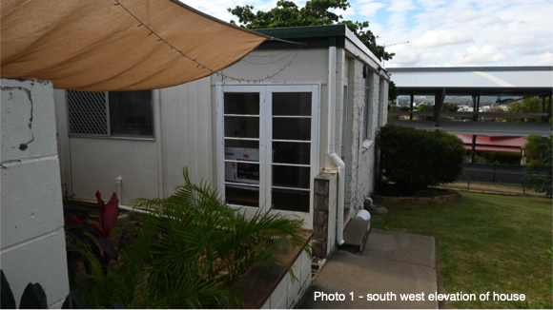 | 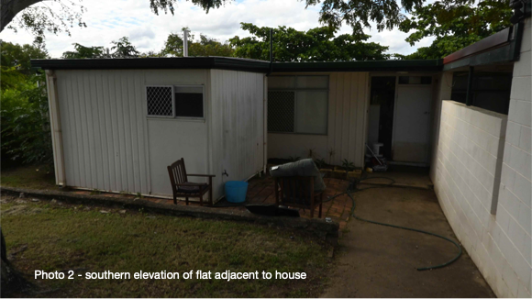 | 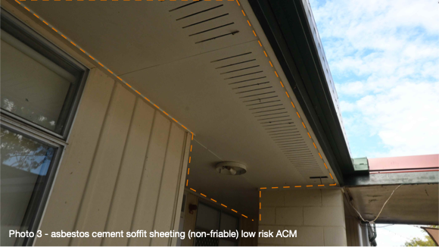
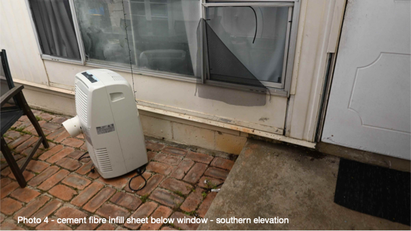 | 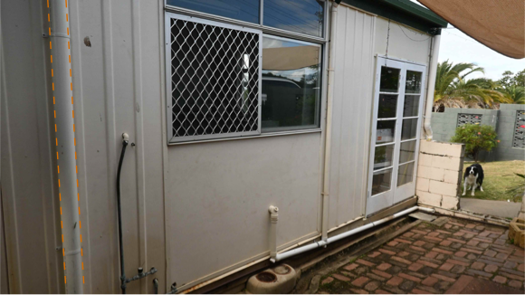 | 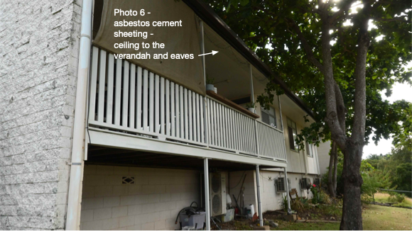
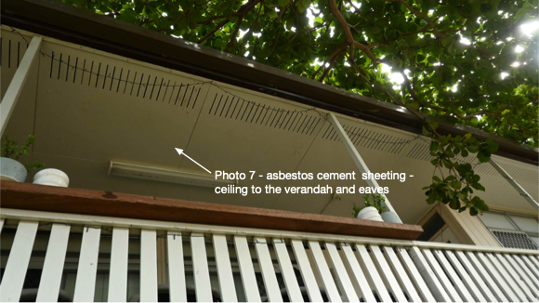 | 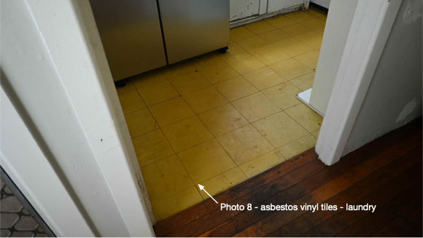 | 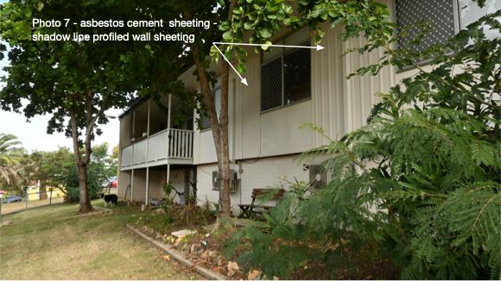
Page 5 of 5

